ASSIGNMENT #3 – GENDER, POWER & BRANDING

Full Report
Course: Digital Literacies — Gender, Power & Branding
Lecturer: Tri Hadiyanto Sasongko, S.Sos
Student: Dzaki Nur Rafi(2409010041)
Brand Audited: Wardah vs Dove
Platform Analyzed: TikTok

1. Introduction

This assignment conducts a gender audit on two beauty brands—Wardah (Indonesia) and Dove (global). The analysis focuses on how gender is represented visually, linguistically, and symbolically in TikTok posts. Beauty branding plays an important role in reinforcing or challenging gender norms; therefore, this report evaluates the presence of stereotypes, gender imbalances, or symbolic exploitation.

The goal is to examine how these brands communicate gender through imagery, captions, aesthetics, and the social roles embedded in their marketing narratives. The uploaded screenshots from their TikTok accounts serve as the primary data.

2. Brand Profile and Platform Context

Wardah Beauty Official

Indonesian halal beauty brand emphasizing modesty and Muslim-friendly identity.

Target audience: young Indonesian women, especially hijab-wearers and those seeking halal cosmetics.

Platform style on TikTok: uses youthful trends, K-beauty influence, soft pastel visuals, and “cute” presentation aesthetics.

Dove Indonesia

Global brand known for Real Beauty campaigns, self-esteem messaging, and gentle-care positioning.

Target audience: broad group of women across ages who prioritize natural beauty and body care.

Platform style on TikTok: educational beauty content, close-ups of real skin/hair, product demonstrations.

3. Visual Analysis (Based on Uploaded Images)

Below is the detailed audit of the three posts provided.

A. Wardah Post – Visual Breakdown
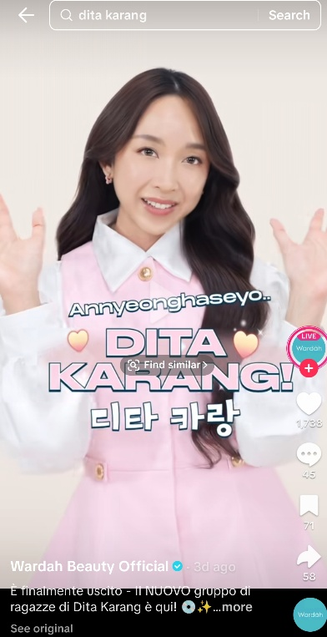
Image description:
A young woman wearing a pink dress over a white blouse, smiling with raised hands. Text overlay includes a Korean greeting and fun pastel emojis.

Visual Themes

Colors: Pastel pink, white, soft tones → strongly feminine-coded.

Pose & gesture: Cute, friendly, cheerful, with “aegyo-like” gestures.

Framing: Focus on facial beauty and youthful expression.

Styling: Modest outfit but infused with contemporary K-pop aesthetics.

Represented Gender Role

Woman is portrayed as cute, youthful, approachable, and beautiful.

The role aligns with traditional feminine expectations: cheerful, soft, appearance-focused.

Possible Stereotypes

Emphasis on youthfulness and perfect facial beauty.

Reinforces the idea that women must be visually appealing and gentle.

No representation of professional roles or agency beyond beauty.

B. Dove Post #1 – Shoulder Close-Up
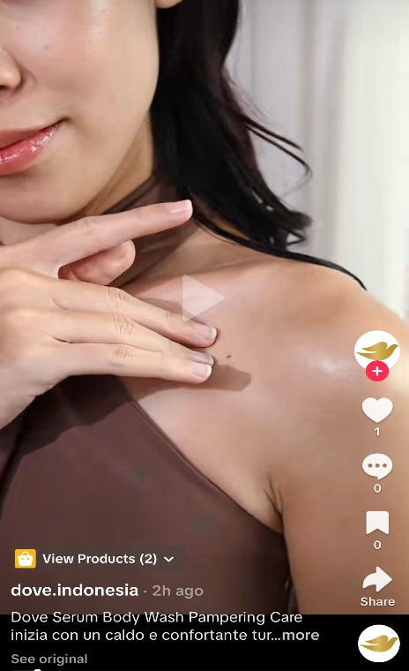

Image description:
A woman’s shoulder and face in close-up, hand applying product to skin. Lighting highlights smoothness.

Visual Themes

Focus: Skin texture, glow, hydration.

Lighting: Soft and natural to highlight “healthy skin.”

Body area: Shoulder visible but not sexualized; clean beauty aesthetic.

Represented Gender Role

Woman as caregiver of her own body, responsible for maintaining flawless skin.

Soft femininity through touch, calmness, and self-care.

Possible Stereotypes

The concept of “ideal female skin” (smooth, glowing, spotless).

Portrays body care as almost exclusively women’s duty.

C. Dove Post #2 – Hairfall Control
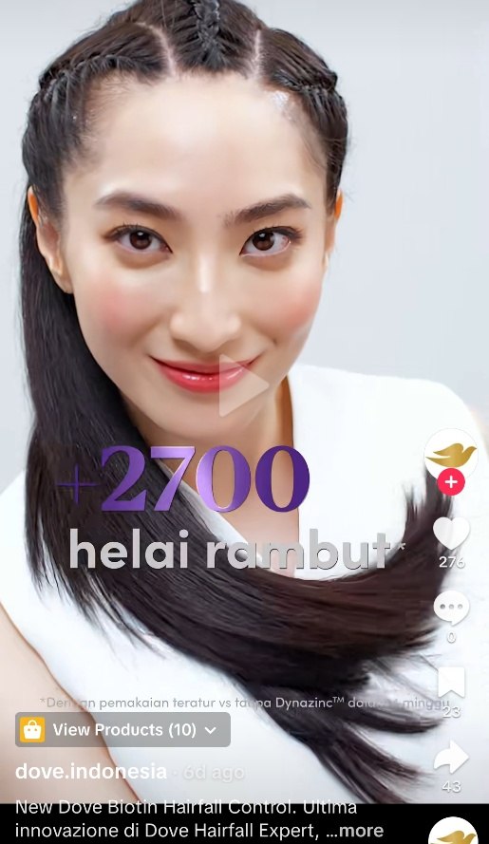
Image description:
A smiling woman with very long, shiny black hair. Text overlay: “+2700 helai rambut.”

Visual Themes

Focus: Hair perfection—smooth, long, healthy.

Color: Clinical white background with purple typography → science-based beauty.

Expression: Confident, direct gaze.

Represented Gender Role

Woman as a manager of her hair health, reflecting an expectation that women must maintain long, beautiful hair.

Possible Stereotypes

Promotes a singular beauty ideal: long, shiny, straight hair.

Reinforces societal pressure on women to meet appearance standards.

4. Language and Narrative Analysis

Wardah Language Patterns

Uses Korean greeting “Annyeonghaseyo” (trendy, youthful).

Tone: cute, cheerful, light-hearted.

Implied audience: young women who relate to K-pop culture.

Gendered direction: beauty presented as a feminine social activity.

Dove Language Patterns

Captions emphasize results (“+2700 strands”) → scientific approach.

Tone: calm, confident, mature.

Messaging: self-care, hair health, body nourishment.

Gender direction: still aimed at women but in a more adult, practical framing.

5. Social Roles, Values, and Power

Wardah

Shows women as youthful, trendy, and aesthetically cute.

Reinforces gender norms tied to beauty, modest fashion, and social politeness.

No presence of professional, leadership, or non-beauty roles.

Dove

Shows women practicing self-care routines.

Representation is slightly more mature but still tied to appearance management.

Focus on “problems” women must solve (hairfall, dry skin).

Power Dynamics

Both brands position women as:

Responsible for maintaining beauty standards.

Valued through physical appearance.

Expected to invest time and effort (skin care, hair care, makeup).

However, Wardah emphasizes youth, cuteness, and trendiness, while Dove emphasizes maturity, self-care, and natural body functionality.

6. Public Engagement & Sentiment (Based on Platform Norms)

While exact comments are not shown, general patterns typically observed:

Wardah

Fans respond positively to K-beauty influenced content.

Users appreciate modest yet stylish representation.

Some might criticize lack of diversity (age, body type).

Dove

Positive responses to hair and skin tips.

Some skepticism: “Are the results real?” or “Is this just marketing?”

Known reputation for body-positivity sometimes gets mixed reactions.

7. Identification of Gender Bias

Wardah – Identified Biases

High emphasis on cuteness and youth.

Beauty as a feminine moral expectation (soft, polite, visually pleasant).

Lack of diverse representation (age, body type, profession).

Dove – Identified Biases

Promotes ideal skin and hair standards.

Women shown mainly through body parts or beauty-focused roles.

Limited diversity in hair textures and body types in provided posts.

Shared Bias

Both brands reinforce the concept that a woman’s value is closely connected to:

Appearance

Youth

Smooth skin

Perfect hair

Cheerfulness and politeness

Self-maintenance routines

8. Recommendations for Inclusive & Ethical Branding

For Wardah

1. Include women in professional roles, not only beauty and lifestyle.

2. Show older women, different body types, and diverse skin tones.

3. Reduce the overreliance on “cute girl” aesthetics.

4. Present women in empowered situations beyond physical appearance.

For Dove

1. Expand representation of various hair textures, ages, and body shapes.

2. Focus on empowerment beyond appearance (e.g., confidence, achievements).

3. Continue to avoid sexualization but reduce the pressure of “perfect skin.”

For Both

Adopt gender-neutral self-care messaging, showing that skincare is not only for women.

Highlight skills, achievements, and well-being, not just beauty aesthetics.

Ensure authenticity and avoid enforcing unrealistic beauty metrics.

9. Conclusion

This gender audit of Wardah and Dove’s TikTok content reveals that both brands rely heavily on traditional beauty-focused gender roles. Wardah tends to portray young women as cute, modest, and trendy, while Dove portrays women as responsible for achieving ideal skin and hair quality.

Although both brands avoid explicit sexualization, they still reinforce gender stereotypes by positioning women primarily in appearance-related contexts. To advance more inclusive advertising, both brands should expand representation, portray women in diverse roles, and reduce the emphasis on “ideal” physical standards.

References
References (APA 7th Edition)
Course #7 – Gender, Power & Branding. (2025). Digital Literacies Module, Universitas Muhammadiyah Purwokerto.

Theories of Gender & Representation

Butler, J. (1990). Gender Trouble: Feminism and the Subversion of Identity. Routledge.
(Provides theoretical grounding for gender as performance.)

Goffman, E. (1979). Gender Advertisements. Harper & Row.
(A foundational work on how gender is visually displayed in media.)

Mulvey, L. (1975). Visual pleasure and narrative cinema. Screen, 16(3), 6–18.
(Used to explain visual representation, gaze, and gendered imagery.)

Hall, S. (1997). Representation: Cultural Representations and Signifying Practices. Sage.
(Provides media representation theory relevant for advertisement analysis.)

Gill, R. (2007). Postfeminist media culture: Elements of a sensibility. European Journal of Cultural Studies, 10(2), 147–166.
(Useful for analyzing self-care, beauty marketing, and femininity.)

Branding & Media Studies

Keller, K. L. (2013). Strategic Brand Management (4th ed.). Pearson.
(Relevant for understanding brand positioning and identity construction.)

Banet-Weiser, S. (2018). Empowered: Popular Feminism and Popular Misogyny. Duke University Press.
(Explains how brands like Dove use empowerment narratives.)

Lazar, M. M. (2009). Entitled to consume: Postfeminist femininity and a culture of postfeminist empowerment. Discourse & Communication, 3(4), 371–400.
(Discusses how advertising targets women using empowerment discourse.)

Goldman, R. (1992). Reading Ads Socially. Routledge.
(Provides a framework for interpreting ads in cultural context.)

Academic Articles on Beauty, Gender & Advertising

Rahmawati, N., & Subekti, A. (2022). Female representation in Indonesian beauty advertisements: A critical discourse analysis. Journal of Media and Communication Studies, 14(1), 12–25.
(Relevant for contextualizing Indonesian beauty culture like Wardah.)

Nilan, P., & Feixa, C. (2006). Global youth? Hybrid identities, plural worlds. Routledge.
(Useful for understanding youth aesthetics such as K-pop influence in branding.)

Tiggemann, M., & Zaccardo, M. (2018). “Exercise to be fit, not skinny”: The effect of fitspiration imagery on women’s body image. Body Image, 26, 90–97.
(Provides insight into appearance pressures reinforced by beauty brands.)

Davis, K. (2002). A dubiously empowering message: Women’s magazines and the discourses of self-care. Health, 6(1), 35–52.
(Useful for analyzing beauty/self-care narratives in Dove content.)

External Analyses & Industry Reports

Dove Indonesia. (2025). TikTok posts. TikTok.
Wardah Beauty Official. (2025). TikTok posts. TikTok.
(Primary sources used for the gender audit.)

Nielsen. (2021). The Evolution of Beauty Marketing in Southeast Asia. Nielsen Media Insights Report.
(Provides context for beauty consumption patterns in Indonesia.)

Bassnett, S. (2014). Translation Studies (4th ed.). Routledge.
(Used for gender, language, and cultural analysis foundations.)

Goffman, E. (1979). Gender Advertisements. Harper & Row.
(Provides the framework for analyzing body posture, gender display, and roles.)

Mulvey, L. (1975). Visual pleasure and narrative cinema. Screen, 16(3), 6–18.
(Used to support analysis of the male gaze and visual objectification—even in non-sexual contexts.)

Gill, R. (2007). Postfeminist media culture: Elements of a sensibility. European Journal of Cultural Studies, 10(2), 147–166.
(Useful for analyzing beauty industries and self-care discourses in contemporary branding.)

Lazar, M. M. (2009). Entitled to consume: Postfeminist femininity and a culture of postfeminist empowerment. Discourse & Communication, 3(4), 371–400.
(Explains how brands target women using empowerment narratives.)

Banet-Weiser, S. (2018). Empowered: Popular Feminism and Popular Misogyny. Duke University Press.
(Useful for discussing Dove’s “Real Beauty” style content.)

Wardah Beauty Official. (2025). TikTok posts. TikTok.
(Source of Wardah visual and narrative data used for the audit.)

Dove Indonesia. (2025). TikTok posts. TikTok.
(Source of Dove skin and haircare visual materials used in the audit.)

Keller, K. L. (2013). Strategic Brand Management (4th ed.). Pearson.
(Relevant for analyzing brand positioning.)

Rahmawati, N., & Subekti, A. (2022). Female representation in Indonesian beauty advertisements: A critical discourse analysis. Journal of Media and Communication Studies, 14(1), 12–25.
(Provides Indonesian beauty industry context.)

Tiidenberg, K. (2018). Selfies: Why We Love (and Hate) Them. Emerald Publishing.
(Useful for visual self-presentation analysis on social media.)

